Class notes Data driven astronomy

Contents

Pulsars

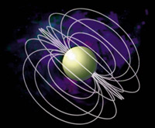In the 1930s, astronomers Volta Badda and Fritz Zwicky were searching for an explanation for supernova. When the sub-atomic particle called the neutron was discovered in 1932, Badda and Zwicky realized it could solve their problem. They suggested that when an old large star runs out of nuclear fuel, it rapidly collapses under its own gravity. The star's core suddenly transforms into a super dense ball of neutrons, and the outer layers of the star bounce off in a massive explosion of light and energy, a supernova. The dense core of neutrons that remains behind, dubs a neutron star, would have the mass of two or three suns squeezed down into the size of a large city.

The law of conservation of angular momentum says, that when a star collapses the rotation speeds up. So, a neutron star could be spinning anything from once a second to tens or even hundreds of times a second. Like the Earth, stars have magnetic fields. And when a star collapses, it takes the fields with it. Neutron stars would have incredibly intense magnetic fields. Charged particles in the super-hot plasma surrounding a neutron star, would get funneled towards the stars magnetic poles and shot out into space as two intense beams.

The pulsar discovered by Bell and Hewish is now called PSR B1919+21: PSR stands for Pulsating Source of Radio and B1919+21 indicates the position of the pulsar in the sky. Even though pulsars were first discovered as radio sources they have now been observed using optical, X-ray and gamma-ray telescopes.

The time interval between consecutive pulses is called the pulsar's period. Periods of one second are typical although pulsars have been discovered with periods from a few milliseconds (one millisecond equals 0.001 seconds) up to eight seconds. The time between pulses is incredibly regular and can be measured very precisely. For example, a pulsar called PSR J1603-7202 is known to have a period of 0.0148419520154668 seconds. However the periods of all radio pulsars are increasing extremely slowly. The period of PSR J1603-7202 increases by just 0.0000005 seconds every million years! There are two main types of pulsar. Those with periods of a few milliseconds and whose periods are changing very slowly are called the millisecond pulsars. The remainder are simply called the "ordinary pulsars".

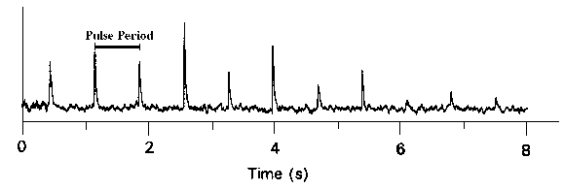

This plot displays pulses from the pulsar PSR B0329+54. The time between two pulses is called the pulse period. The pulses can look very different from each other in both shape and height as seen in the plot.

Each pulse is found to be made up of radio waves of different frequencies just as white light is made up of all the colours of the spectrum. It is observed that the highest frequencies of a pulse arrive at a telescope slightly before the lower frequencies. The reason for this is that the pulse has been travelling through the interstellar medium (the space between the pulsar and the Earth) and the different frequencies making up the pulse travel at different speeds through this medium. This is referred to as the pulse dispersion and is due to the free electrons in the interstellar medium. The more distant pulsars are dispersed more than the closer ones and so the time delays between the different frequencies can be used to estimate an approximate distance to a pulsar. Except for a few pulsars in our neighbouring galaxies, the Magellanic Clouds, most pulsars are found to be well outside of our solar system but within our Galaxy. The youngest are found to lie within the plane of our Milky Way Galaxy. The very youngest are found within supernova remnants which suggests that they were probably "born" during the explosion of a massive star. The fastest pulsars will never come back - they will escape from the Galaxy and will travel off into the space between galaxies becoming undetectable. Others will slow down and then drop back towards the plane of the Galaxy and will continue to oscillate up and down for the rest of their lives.